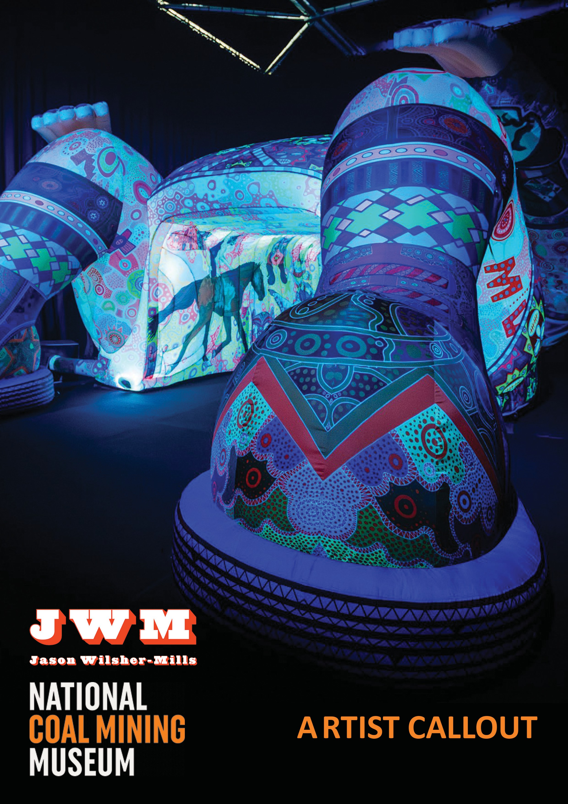

Call Out: Jason Wilsher-Mills and National Coal Mining Museum for England

Commission programme for disabled artists with mentorship and support.

- Are you a disabled creative who is inspired by coal mining heritage and its impact on people and places?

- Would you like the time, space and support to create new work, through delivery of a new commission?

- Would you like to receive mentoring sessions from artist Jason Wilsher- Mills?

Then this bespoke mentoring, learning and commission opportunity may just be for you!

About the Programme

Spread over seven months (January 2026-August 2026), the programme offers the chance to create new commissioned artwork for the National Coal Mining Museum for England with support from an experienced artist mentor, Jason Wilsher-Mills.

This newly commissioned work will support new large-scale artwork that Jason is creating for the National Coal Mining Museum for England and accompanying exhibition at the Museum which will also tour nationally. (There is an opportunity for the commissions to be also shown digitally alongside Jason’s work)

We have 3 micro commissions available on this programme which is open to disabled artists based in, or with connections to, former coalfield communities across the UK. Each selected artist will work to create new art, which will be exhibited at the National Coal Mining Museum in Wakefield, and/or its touring partners/community venues local to them.

The appointed artists will work with communities to explore what culture means to local people in their place, resulting in the development of a wide range of creative outputs, inspired by the engagement process.

Through the process artists will have the chance to reflect on their progress, both individually and with their mentor and peers, in order to inform their future practice.

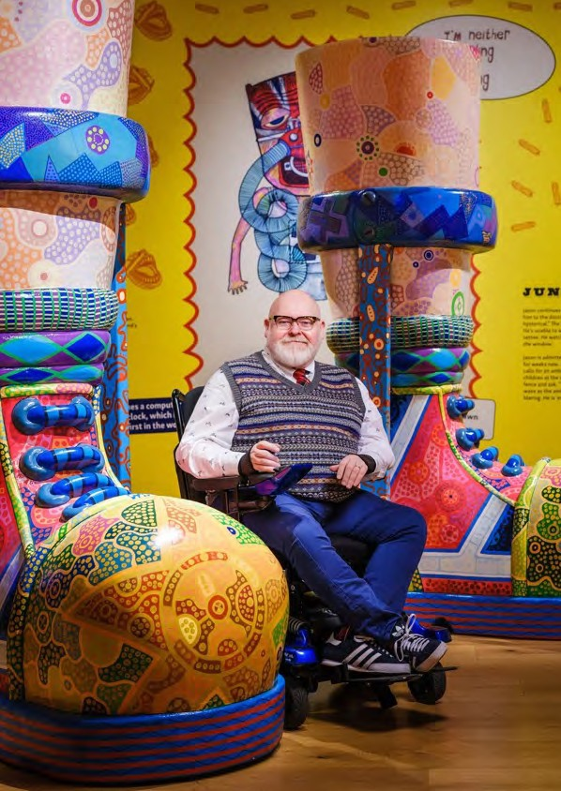
Jason Wilsher-Mills

About the artist.

“My work celebrates disability, my northern working- class heritage & popular culture, through cutting edge technologies and brightly coloured, largescale humorous, but challenging art. When asked what my work is about, I simply say – ‘Think ‘I, Daniel Blake’ meets ‘The Beano’”

Jason Wilsher-Mills is an artist who was born in Wakefield, West Yorkshire in 1969. He grew up in a large working-class family, on council estates in Ossett, Gawthorpe & Eastmoor. His father was a coal miner. He fell ill with chicken pox in 1980, when he was 11 years old, with the virus attacking his central nervous system, causing him to be confined to a wheelchair.

This experience has been pivotal in his creative practice, as his work reflects the stories relating to his disability, class, family, activism and popular culture, through large sculptures, augmented and virtual reality, along with digital painting.

He uses both digital and traditional media to create the work, which is brightly coloured and psychedelic, employing a palette inspired by the childhood comic books he read in the 1970s. He uses humour to tell sometimes serious and challenging stories.

In 2020 he was awarded the Adam Reynolds Award by SHAPE Arts. He has exhibited around the world, including the 2024 Venice Biennale and at Wellcome Collection. His work is also part of the Government National Collection and at Ferens.

Aims of the Programme
To coincide with a major new exhibition by Wakefield-born artist, Jason Wilsher-Mills, at the National Coal Mining Museum for England, we want to support disabled artists, to be given opportunities to grow their skills and confidence, and deliver micro commissions, with funding of £2,000 for each commission + £500 towards materials. The programme is designed to be flexible and respond to the needs of participants. You will be asked to complete an artist’s access assessment as part of the application, which will be used to help shape the programme.

About You
- You will have a passion for developing accessible and ambitious creative responses, inspired by ex-mining communities and places
- You will have a keen interest in engaging with people as part of your artistic practice.
- You will be highly motivated to use this professional development opportunity to take your development as an artist to the next level
- You will be committed to working with mentors to create a supportive and creative shared learning environment

The Benefits
- You will have the opportunity to develop a new micro commission in collaboration with a specific community, with ongoing advice and support
- Peer to peer support & mentoring with the artist, Jason Wilsher-Mills on the programme including peer group feedback sessions and networking
- Understanding about what is involved in co-creating artworks in a socially engaged way and varying approaches
- Knowledge of the practical considerations when working with communities
- Increased connections and networking in the sector
- Signposting to further opportunities and networks

What will it involve?
- Following selection, you will have a 1-2-1 online meeting with Jason Wilshire-Mills and team to outline your aspirations for the programme and to support you to develop a mentoring plan and to help us to identify the most appropriate mentoring relationship for your needs. We can also review your application responses and answer any queries or questions you may have at this point, including access needs. We will ask you to sign up to a mentoring agreement.
- The sessions will commence with an in person (where possible, depending on locations of participants) ‘setting the scene’ group session, providing inspiration from socially engaged projects and exploring approaches to co-creation with
communities.
- There will be a mix of in-person and online 1-1 sessions with mentors to discuss progress.
- There will be an interim group session to reflect on progress.
- By (May 2026), each mentee will present how they plan to share their creative outcomes - this may be via: exhibition, installation, print, digital, sound etc.
- Upon completion the cohort will meet in person to reflect on successes and challenges of their projects.

Process & Timeframe

ACTIVITY | TIMING
Applications Open | Friday 7 November 2025
Zoom drop-in session for queries on the application process: please email exhibition@ncm.org.uk to be sent link | Monday, 24 November
Deadline for applications | Friday 5 December, 5pm
Clarification phone calls as required | w/c 10 December
Artist cohort appointment | By Friday 9 January
Initial online meeting with JWM/NCMME | w/c 12 January

Getting Started | w/c 19 Jan 2026
Installation of works | From June 2026
Exhibitions and public engagement | From July 2026
Creative Outcomes & Celebration | From August 2026
1-2-1 meetings with mentor | Up to 2 sessions per person - timing and format to be agreed

Key Details

An opportunity for ambitious disabled artists seeking to develop their existing artistic practice in terms of community/social engagement and receive mentoring from artist Jason Wilsher-Mills. They will also be part of an ambitious celebration of new art, which will support JWM’s new exhibition at the National Coal Mining Museum for England (opening March 2025)

Fee
  - A fee of £2,000 (+ VAT if applicable) is available per artist, to include all fees and expenses
associated with participation in the mentoring and learning activities, and with the delivery of an artistic commission as an outcome of the programme
  - £500 towards materials
  - Working with your mentor you will be supported to develop a budget for your commission and to work within the constraints of this.
  - Payments will be staged and will align with the artist meeting specific milestones which will be mutually agreed as part of a formal agreement.

Access & Support
  - If you require support or have any access requirements to complete the application process please do not hesitate to contact us via the details below.
  - If you have an Access document you can attach this to your application.
  - The application form provides space for you to provide details about any access support you may require in order to participate in the programme. If you would like a conversation
about your access needs to participate - please get in contact with us directly. There will be funding available (up to £600 per commission) to support access needs, such as travel, etc.
  - We will support the programme to be a safe space for our cohort of artists by agreeing a set of safe space guidelines with the group at the first orientation session. These will broadly follow those set out by the Social Art Network ‘Safer Spaces Agreement’.

LOCATIONS: National Coal Mining Museum for England, online. We will utilize accessible venues.

EQUAL OPPORTUNITIES: We encourage applications from those currently under-represented in the arts sector. We welcome applications from all regardless of their age, gender, sex, sexual orientation, ethnicity, disability, neurodivergence, religion or belief, occupation, caring responsibilities or lived experience.
PARTNERS: This programme is being developed and delivered by artist, Jason Wilsher-Mills in partnership with National Coal Mining Museum for England. It is funded by Arts Council England.

Application Process and selection criteria
  - We are seeking three ambitious disabled artists based in former coalfield communities across the UK, working across a broad range of artforms.
  - Deadline for applications Friday 5 December 2025, 5pm
  - Applications will be scored on submissions and will be appraised on the potential for impact on the applicant’s future career.
  - Clarification calls may be sought w/c 10 December prior to final selection decisions. There will be no interviews
  - To apply please complete the attached application questions including a 500 word statement detailing why you would like to be part of the commission programme. Please also send 2 files of your work.
  - Please send to: exhibition@ncm.org.uk
If you have any questions about this programme or the application process then please
  - join us for a Zoom drop in session on 20 or 24 November when you can ask any questions of the project team. Please email exhibition@ncm.org.ukto book your space.
  - Please contact us if you would prefer to send your application in an alternative format such as a video or audio recording.

For all enquiries please contact: exhibition@ncm.org.uk pa@jwmartist.co.uk

Programme delivered by:
Email: jason@jwmartist.co.uk Instagram: @wilshermills
